Line Following Robot with Tiva Board
Amit Manchanda (14116069), Swabhiman Patnaik (14116069)

Abstract—The line following robot is microcontroller equipped mini car, which can detect contrasting lines on the floor and drive over them. These kinds of robots are mostly make use of differential drive to steer left or right to stay on the line and implement the PID controller to smoothen the movements of the robot.
Index Terms—Line Following, PID controller, PWM drivers, differential drive.

Introduction

Today, every industry thrives on the exploits of robots in various fields. These robots can perform tedious monotonic tasks at high speed and high accuracy. They are also deployed in field that are dangerous to human lives, hence increasing work security. The line following robots find extensive use in warehouse and transport departments. The transport robots can use extensively laid grids to navigate through warehouse or factories and it is a easy and effective means of positioning.

The Tiva™ C Series ARM Cortex-M4 microcontrollers provide top performance and advanced integration. The product family is positioned for cost-conscious applications requiring significant control processing and connectivity capabilities. In addition, the TM4C123GH6PM microcontroller offers the advantages of ARM's widely available development tools, System-on-Chip (SoC) infrastructure IP applications, and a large user community.

Design procedure

The robot will be a 3-wheel, differential drive car with 2 driving wheels in the back and one castor wheel in the front. Two 100 rpm motors will be used along with a dual motor driver to power the bridge the microprocessor and motors. A line array IR sensor will be used to detect the line (path). For remote control, Bluetooth module is proposed which will enable communication with smart phone. Finally, the robot will be powered by 9 V Li battery, whose voltage is stepped down inside the motor driver to 5 V.

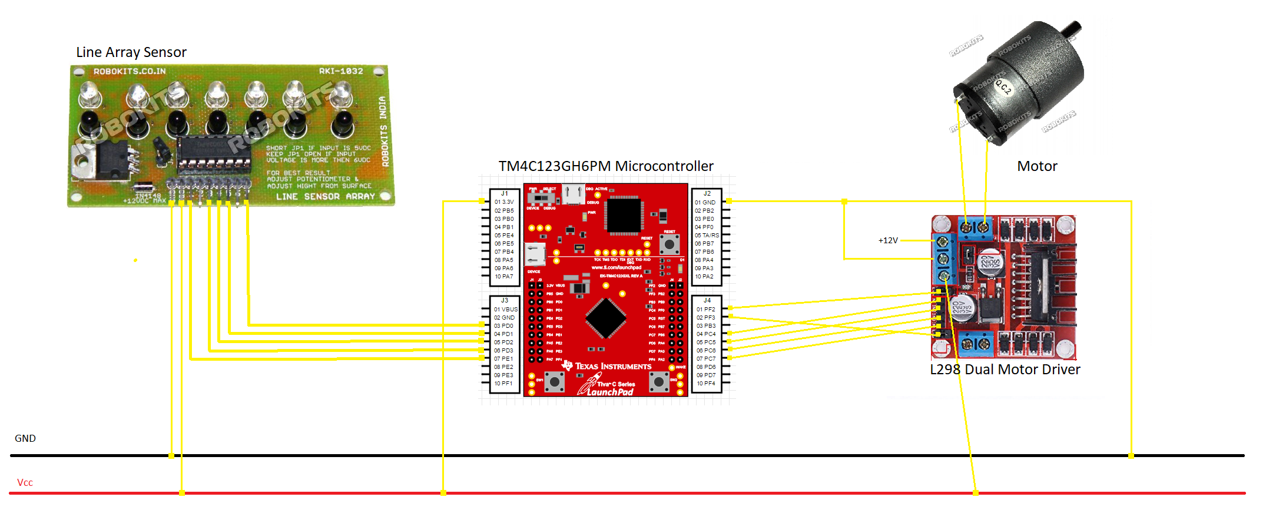
Fig. 1 Hardware design of the robot
The digital input from 5 sensors of the array sensor are fed into the microcontroller with the help of jumpers. These readings are used to find the relative position of the robot with respect to the line. The robot is considered to be on the line when the middle sensor is directly above the line. This is the ideal condition and when the robot deviates from this position, an error is generated. This error is calculated using a weighted sum approach:-

s[i] is the array in which the sensor readings are stored.

s[i] = 0 when the sensor is above white surface
- when the sensor is above black surface

sum = ∑ s[i]

wsum = ∑ 2*(i-2)*s[i]

err = wsum/sum (if sum ≠ 0)

err = pre_err (if sum = 0)
(where err is the error and pre_err is the previous error)

In the weighted sum approach, we assign a weight value to each sensor depending on its position. The central one is given the value 0 as it is the ideal condition. As we move away from the center the magnitude of the weights increase, but the sign depends on which side of center it lies on. In the above equation, the weights are (-4,-2,0,2,4) from left to right.

It is important to notice that if the robot completely deviates away from the line then all sensors will give 0 reading and the value of sum will become 0 giving the case of division by 0. So if such a case arises, then the error is set to the previous value of the error.

The error value obtained above is fed into a PID algorithm to calculate the correction to be added to the speed of the motors. In this project, we have used proportional and differential controller. The equations used are :-

corr = k_{p}*err + k_{d}*derr

where derr = err – pre_err

right_pwm = base_pwm + corr
left_pwm = base_pwm – corr

where base_pwm is the base speed of the motors
corr is the correction
derr is the differential of error
right_pwm and left_pwm are the PWM inputs given to right and left motors respectively.

So, the final pseudocode will be as follows :-

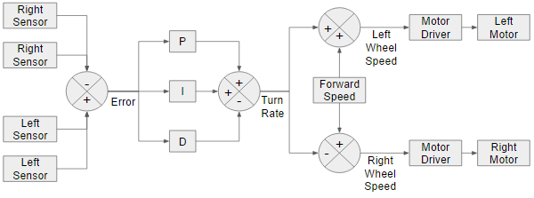
Fig. 2 Software Design in flowchart

//Start of loop
//Obtaining the sensor readings
for(i = 0 : 4)
s[i] = GPIO_PORTB_DATA_R & (1 << i)

//Calculating the value of error
pre_err = err
for(i = 0 : 4)
sum = sum + s[i]
wsum = wsum + 2*(i-2)*s[i]
if(sum == 0)
err = pre_err
else
err = wsum/sum
derr = err – pre_err

//Implementation of PID controller
corr = k_{p}*err + k_{d}*derr
right_pwm = base_pwm + corr
left_pwm -= base_pwm – corr

//Powering the motor through a motor driver
Right_motor_in1 = 1
Right_motor_in2 = 0
Left_motor_in1 = 1
Left_motor_in2 = 0

Right_motor_pwm = right_pwm
Left_motor_pwm = left_pwm
//End of loop

The motor input1 and input2 are required to set the direction of rotation of the motors. Swapping the values of both inputs reverses the direction of rotation. Setting both the inputs to either ‘1’ will stop the rotation.

Design challenges and trade-offs
One of the major challenges in the designing of the robot was determining the values of proportionality and differential constants (k_{p} and k_{d}). The values of these two constants are set up experimentally and it takes several trials to get an optimum result.

The value of k_{p} determines how fast the robot steers back to the line after it deviates. For a higher value of k_{p}, the rate of turning will be high but it will also increase the overshoot. The differential constant k_{d} decreases the overshoot but it also reduces the rate of turning. The values of the two constants are set keeping in mind the trade-off between these two factors.

Experimental results
The line following robot was made using the above procedure and the values of k_{p} and k_{d} were determined by running the code multiple times. The final values were determined as –
k_{p} = 10000
k_{d} = 1000
The robot was able to trace a free-form line drawn on the floor with minimum deviations. It was also able to make sharper turns in case of larger curves.
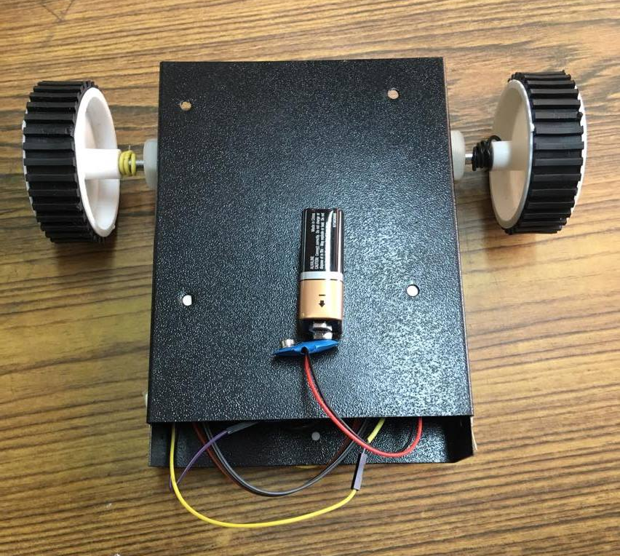
Fig. 3 Line Following Robot final prototype
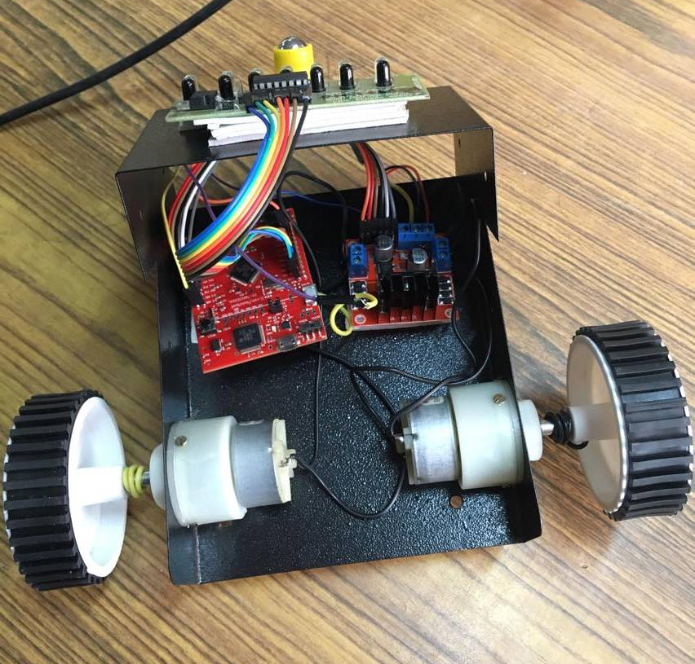
Fig. 4 Extensive View of the robot
Conclusions
In its current form robot is enough capable. It can follow any curve and cycle. We must build a robot that has light weight and high speed because points are awarded based upon the distance covered and the speed of the overall robot. Therefore, we used two high speed motors and high sensitivity sensors circuit. The body weight and wheels radius have effects on speed, too. The weight of the designed robot is around 300 grams and it can be lighter. To get better maneuver, we must build a robot that uses two motors and two wheels on the rear and a free wheel on the front. The power supply is 12 with regulator. The designed robot has eight infrared sensors on the bottom for detect line. Microcontroller ATMega16 and driver L298 were used to control direction and speed of motors. The robot is controlled by the microcontroller. In performs change the motor direction by giving signal to driver IC according to receives signals from sensors.

Acknowledgements

We acknowledge financial and technical aid for this project received from Dr. B.P. Das and Digital Electronics Laboratory, Department of Electronics and Communication, Indian Institute of Technology Roorkee.

References
- Mehran Pakdaman and M.Mehdi Sanaatiyan, "Design and Implementation of Line Follower Robot", International Conference on Computer and Electrical Engineering, 2009
- Valvano, J. “Embedded Systems: Introduction to ARM Cortex-M Microcontrollers, 2016”
- Instruments, Texas “TivaTM TM4C123GH6PM Microcontroller Datasheet”

